Assignment 1

*WEB701 - Design for and Evaluate web technologies to develop a website.*

Jackson Hayes

NMIT ID - 13521772

S2 2024

Table of Contents

Design – Milestone One 3

Project Brief 3

Site Goals 3

Mission Statement 3

Short & Long Term Goals 3

Intended Audience 4

Why will people come ot the website? 5

User Experience 5

Audience Analysis 5

Scenario One 6

Scenario Two 7

Scenario Three 8

Competitive Analysis 9

Site Content 15

Content and Functional Requirements 15

Grouping and Labeling 16

Site Structure 17

Metaphors 17

Site Structure Listing 18

Architectural Blueprint 19

Define Navigation 20

Visual Design 21

Home Page 21

About Us Page 21

Contact Us Page 23

Register/Login Page 24

Profile Page 25

Donation Dashboard Page 26

Recipe/Health Tip Page 27

# Design – Milestone One

## Project Brief

The Grow & Give charity is a food donation charity in the Nelson region who offer local fresh produce to the community. We need a website for the Nelson region for members of the charity to provide fresh produce and excess product that is still usable. The charity is initially aimed at donating locally sourced fresh fruit, vegetables and berries but has potential to expand into all food item donations in the long-term.

The purpose of the new website is to help with the distribution of the service or product by members of our charity to customers. Like a “food bank”, the website lets members register and describe the service or products they are providing, the number and frequency of the offerings. The website lets members of the community (beneficiaries) access the service, by providing tokens that can be “spent” in the service. To achieve our goal, we would like to have an online token function on our website that let a beneficiary access a limited number of tokens, for example the system needs a mechanism that verifies that a member of the community is accessing the service and that the token belongs to a particular community member. The website needs some homepage text about general information of our products and services such as: types, characteristics, quality factor, usage and benefit.

We require the following features on the website:

1. Charity members and beneficiaries can register, log in and administer their own accounts.
2. Members use the website to register their products and services, and beneficiaries use the system to acquire tokens.
3. Interactive element(s) that engages the website user.
4. The system provides an interface that the members can use to accept a token in a transaction.

## Site Goals

### Mission Statement

The Grow & Give charity service website aims to bridge the gap between local farmers/growers and members of the community in need by providing a platform for donating and distributing excess fresh berries and usable produce. The goal is to promote healthy eating, support the local businesses and agriculture, and ensure that no one in the community goes without easy access to nutritious foods.

### Short & Long Term Goals

1. The website is initially aimed at donations in the form of fresh produce like berries or vegetables as there is a lot of local agricultural farms/businesses that could contribute to the charity. A long term goal of the website/charity would be to gradually move to more of a foodbank style charity with donations of any type of food being accepted to boarded the reach and improve the amount of donations the charity is giving. This could then be used by restaurants or bakeries that have excess products at the end of the day that are still good to eat and could be offered for donation.
2. To create a platform that can facilitate donations from local berry growers, farmers or supermarkets to donate fresh berries or excess produce that is still usable. The initial and early-stage goals is to have a working system with distribution being a ‘click-and-collect’ approach. A long-term goal is enabling a distribution service for these donations to be delivered directly to community members that are in need which will also improve the accessibility of the charity service by being accessible to those who may not be able to collect the donation personally.
3. To promote healthy eating and ensure members of the community have easy access to fresh, locally sourced and nutritious produce. The long-term goal of this is to have a website and platform to educate the community about health benefits and various uses of prouce through informative content and recipes.
4. Supports local agriculture by creating a connection between local growers/farmers and the community through their donation service. The charity and website responsible for giving donations will be another way of highlighting quality produce that is locally grown, further promoting local farmers.
5. The website will implement a fair system that utilizes vouchers to ensure equal distribution of the donations, allowing beneficiaries to access a limited number of vouchers to acquire the donated produce. Ideally in the long-term, there could be the implementation of some verification mechanisms to make sure vouchers are only given to registered community members to main the integrity and transparency of the charity organization.
6. Although it is a charity and website aimed at giving locally sourced produce donations to community members in need, there could also be a long-term goal of adjusting this to allow for anyone to receive donations which would tie into the last point previously mentioned of having a system to verify beneficiaries and prioritize the community members who are in need. This could mean that those in need get the fresh produce, while others only have access to the excess produce in limited supply.

### Intended Audience

There are 2 main groups in the intended audience but also contains many subgroups that the website and charity apply to. The first main group are the local farmers, growers and businesses involved berry farming/harvesting and are interested in donating their produce to the community in need. The second group are community members in need. This includes individuals and families who would benefit from receiving fresh produce.

While it is a charity service and website aimed at donating fresh local produce to community members in need by providing food that is nutritious, healthy and like by many, it can also be a place for other groups of people to receive local produce. These other groups include but aren’t limited to:

1. General public/Community supporters
2. Health-conscious people
3. Commercial hospitality businesses (Restaurants, Cafes, Bakeries, etc.)

### Why will people come ot the website?

1. Donators will come to the website to easily register and manger their berry donations which will contribute to the community and people in need. This will also give the donors visibility and goodwill for their contributions
2. Beneficiaries will come to the website to access fresh and nutritious produce, learn and understand about the health benefits of eating healthier whole foods and be apart of a supportive community.
3. Health-conscious people and/or the general public can use the website to apply for excess produce that is still usable (making sure the community in need are prioritized first) or to find recipes, health tips and information on the benefits of eating clean food.
4. Supports will come to the website to support local agricultural and community enhancing projects that aim to give to people in need.

## User Experience

### Audience Analysis

As mentioned in the section above, the intended website audience is almost split into two groups with the first group consisting of produce/berry donators and beneficiaries (community members in need) and is the primary reason for the website. The second group can be seen as anyone else who would use the website including but not limited to the general public, businesses, supporters, health-conscious people, etc. Although both groups for the websites intended audience share an equal weight of importance in the development of the website, it is still a charity service which primarily aims to help community members in need.

Here is a more in-depth analysis of the website intended audience:

* **Local Berry Growers/Farmers:** Individuals and businesses involved in berry farming with excess produce who are wanting to donate to community members in need.
* **Beneficiaries:** Community members in need of healthy whole foods including low-income families/individuals, elderly members and individuals with limited access to nutritious food.
* **Health-conscious individuals/General public:** People interested in the benefits of healthy eating and looking for recipes or wellness information. A long term goal for the website is to allow others to apply for fresh produce assuming community members in need are prioritized first. (This concept is still a work in progress)
* **Community supporters:** individuals and businesses that want to support local agriculture, sustainable practices and projects that help people of the community in need. Businesses who are also looking to partner with the charity for evens and promotions.

### Scenario One

**Persona:** John the Berry farmer

* **Name:** John
* **Age:** 45
* **Occupation:** Berry Farmer
* **Background:** John has been the owner and operator of a local family run berry farm for the last 20 years. He is dedicated to sustainable practices and often has surplus berries or produce that isn’t quite up to quality standards that he wants to donate to reduce waste and support the community in need.
* **Goals:**
  + Reduce the amount of excess produce
  + Support the community and members in need
  + Increase and gain positive visibility of his business/farm
* **Pain Points:**
  + Not having a way to manage surplus produce
  + Finding reliable and ethical distribution services to ensure donations reach those who need them most
  + Balancing time between his job and coordinating donations

*“As a berry farmer, I want to be able to easily register and manage my donations so that I can contribute to excess produce without hassle. I want to donate my surplus berries to the community to help reduce wasted food and support local families/individuals in need”*

John hears about the Grow & Give charity service and sees it as an excellent opportunity to donate his excess berries. As a user of the Grow & Give web app, John would like to do the following:

* Register as a donor with his contact information, including business name, location and types of product he typically grows.
* Be able to list the types and quantities of berries available for donation, providing information for pickup or handling instructions
* Manage any listings through a dashboard where he can update the quantities, pickup schedule, etc.

The outcome of John using the charity website to successfully donate his surplus berries means he feels gratifies knowing that his what would be wasted produce is helping those in need and contributing to the community. Additionally, his farm gains a positive reputation for being involved with charity and helping reduce food waste.

### Scenario Two

**Persona:** Sarah the single mother

* **Name:** Sarah
* **Age:** 32
* **Occupation:** Part-time retail worker
* **Background:** Sarah is a single mother of two children. She works part-time and lives week to week when it comes to managing her funds. She is always looking for ways to provide healthy food for her children on a tight budget.
* **Goals:**
  + Provide healthy food for her and her family
  + Manage on a tight budget while ensuring her children eat well
* **Pain Points:**
  + Limited access to affordable fresh and nutritious produce
  + Balancing work, childcare and meal preparation
  + Finding reliable sources of healthy food on a tight budget

*“As a single mother and part time worker I sometimes struggle to provide nutritious and healthy food for my family. I want to apply for vouchers so I can get regular access to fresh produce when needed so that my family can live a healthy lifestyle instead of eating junk food.”*

Sarah learns about the Grow & Give charity service and is excited to take the opportunity to receive fresh produce for her and her children. As a user of the Grow & Give web app, Sarah would like to do the following:

* Sign up and register a beneficiary account that includes her details, contact information and verifies her eligibility for the donation service
* See the available vouchers she can claim which allows her to request fresh berry donations
* Browse existing listings of available produce from local donors
* Redeem a voucher to request an order and receive details about the pickup location and scheduled times (If applicable)
* Have access to recipes and/or health tips on the website to make the most of the fresh produce

By Sarah using the Grow & Give charity website, she can successfully and easily acquire fresh health foods for her family through the donation platform. She will feel relief and gratitude for the support, know that she can provide healthy food for her children without pushing her budget. This will bring a positive experience and encourage her to continue using the service while she needs it.

### Scenario Three

**Persona:** Lisa the Bakery manager

* **Name:** Lisa
* **Age:** 38
* **Occupation:** Bakery Manager
* **Background:** Lisa has been running a small local bakery for the last 10 years where she originally started as a cake decorator and worked her way up to management. She is passionate about baking, helping and being involved with the community. Her bakery often has excess produce at the end of the week due to slow sales or over ordering of ingredients and she hates to see good food go to waste. Lisa wants to contribute to the community by donating her surplus produce (berries and fruit) to those in need.
* **Goals:**
  + Reduce food waste by donating excess produce
  + Support the community and members in need
  + Get a positive reputation and grow her bakery’s image
* **Pain Points:**
  + Not having a way to manage excess produce/ingredients
  + Finding reliable channels to ensure the donations reaches those in need
  + Lack of time to coordinate personal donation services effectively.

As a business owner in the food/hospitality industry, I want to donate any excess ingredients or possibly baked goods that did not sell so that I can support and give back to the community while reducing food waste.

Lisa hears about the Grow & Give donation charity and is excited to finally have the possibility of donating her bakery’s surplus produce. She visits the website and quickly sees an option for businesses to register as donors for the charity. As a user of the Grow & Give web app, Lisa would like to do the following:

* A way for her to register as a donor, which would include a form for her to enter in relevant details, including business name, location and types of donations she has to offer.
* Listing the types and quantities of excess food items she has available to donate for each day with specific pick up locations and times.
* A way for Lisa to manage her donations via a dashboard and see her listings, where she can update, remove or add quantities or product type.

By Lisa using the Grow & Give web app to donate her bakery’s surplus ingredients and baked goods (In a future version of the website) She will feel fulfilled and satisfied knowing that any excess produce is contributing to a good cause by helping those in need within the community. Additionally, her bakery should gain a positive reputation for being involved in a community focused charity and reducing food waste.

### Competitive Analysis

Some of the main competitors for the proposed charity service include existing food bank services, grocery delivery services and potentially community programs that give donations. The Grow & Give website plans on differentiating itself from its competitors by combing aspects of the strengths of each while addressing and taking into consideration their weaknesses. The platform focuses on fresh produce and operates on a donation-based model which ensures community members have access to healthy food. The voucher-based system could be implemented similarly to the foodbank project website, where instead of specific product purchase, the user can redeem a package using a voucher.

In more detail:

* **Food bank services:**
  + Food banks are a significant competitor as they are usually established organizations that donate and provide free food to those in need which is a very similar goal to my proposed charity idea. They will also have well established networks with donors and be known for recommendations. Food banks typically offer a wider range of food items, including canned goods, dry foods, and fresh produce which caters to a wider range of people.
* **Grocery delivery services:**
  + Grocery delivery services such as local supermarket delivery options or privately run businesses aren’t necessarily the biggest competitors against a food bank style charity organization due to groceries still needing to be purchased but should still be considered a competitor since it could share a similar goal of getting food and groceries to their customers. If we take the user story and persona of ‘Sarah the single mother’ I could see grocery delivery services being a competitor and possible first option as it would save Sarah the time and effort to personally get groceries and can all be done at an easy convenience.

Here are some links to New Zealand based charities/business websites which were used to analyze potential competition for the Grow & Give charity. The first two are food donation charities and the last one being a grocery deliver service:

<https://www.foodbank.org.nz/>

<https://www.nelsoncommunityfoodbank.org.nz/>

<https://www.teddy.nz/>

**The Foodbank Project NZ:**

The website itself is very basic in terms of visual design and user interface but that could have also been done with the purpose of remaining simple to use and focus on the goal of the website rather than the visual aspect. The user experience is relatively straightforward, with navigation feeling easy and having clear to read text throughout the website. I believe a strength of the Foodbank project website is the flow of the site, with the landing page containing a brief description of what the project is about and how it works and then has ways to donate and contribute below that. Additionally, the easy to use navigation links make it easy for a user to find what they’re looking for without getting lost, whether it be wanting to donate, get support, or just learn about how it works.

The Foodbank Project website is unique in the fact that it acts as a grocery delivery service but instead of receiving the groceries, they get donated to a foodbank and contribute to food packages given to people in need. The idea of this layout is quite a good idea in my opinion as users get the benefit of choosing what they want to donate specifically and/or how much they would like to donate/spend to contribute. Similarly to a long-term goal of the Grow & Give charity web app, the Foodbank project has a dedicated page filled with different healthy recipes or creative ideas that are budget friendly which helps to broaden their target audience and cater to more than just donors and beneficiaries.

One of their weaknesses in my opinion is the lack of visual design or colour throughout the website and overall looks very bland. While there is nothing wrong with a minimal design for websites, I feel as if there could be more done with the visual design of things to keep the user engaged and wanting to use the website.

*Screenshots for reference below:*

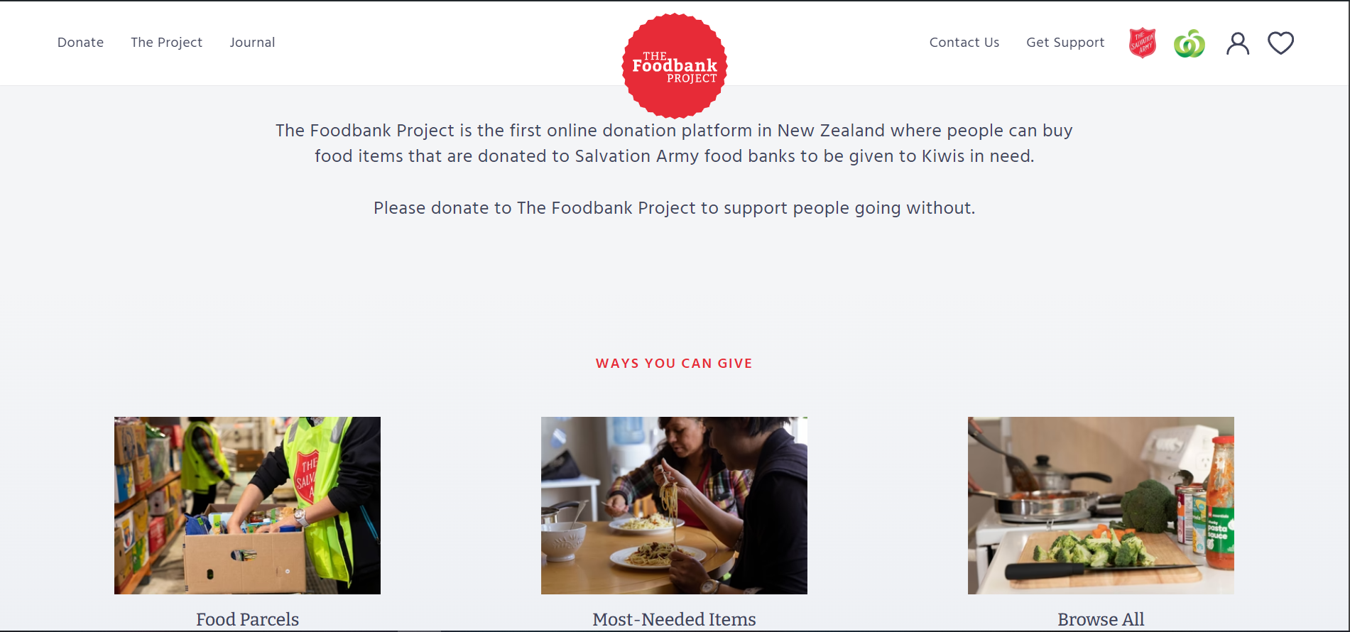

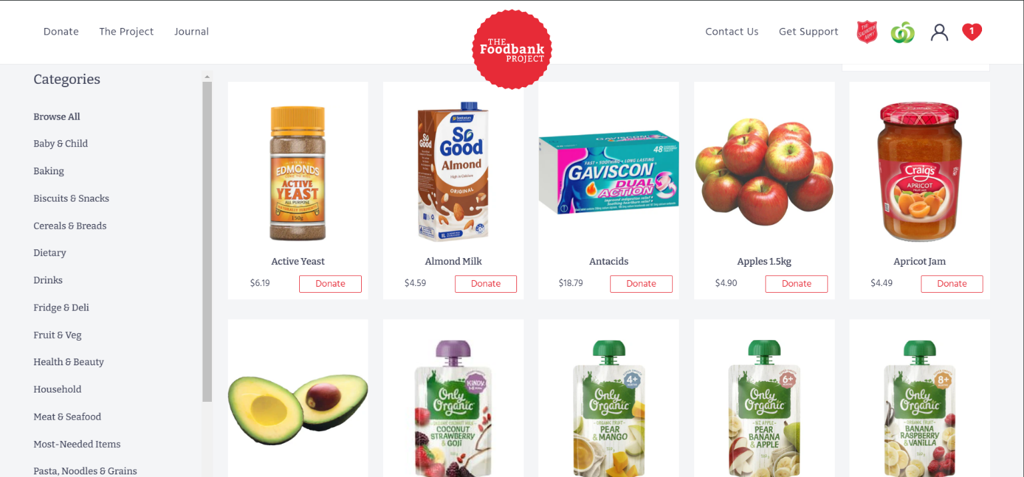

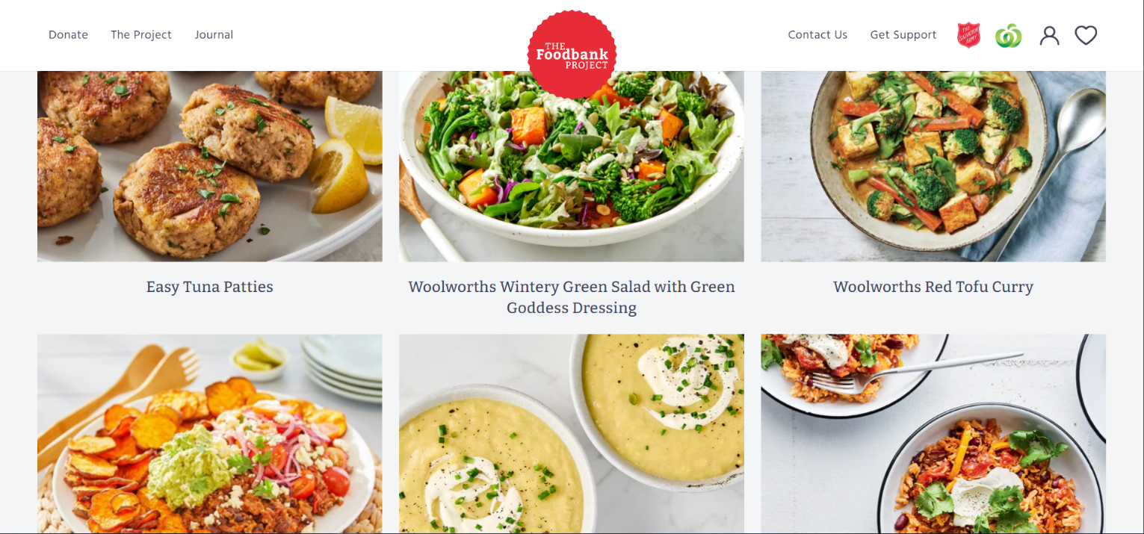

**Nelson Community Food Bank:**

The Nelson Community Food Bank website follows a similar approach to the previous website (The Foodbank Project) by having a good description and ‘about us’ section on the landing page with further information regarding reputative supporters and how to get started as a donor/beneficiary. I find that the initial UX/UI design of the website is simple and follows a straightforward flow. The navigation menu has very relevant and important sections/links.

One thing I noticed about the layout of the website is that all the information is seemingly crammed onto a single webpage with links in the navigation menu repositioning the page to the correct section. I personally don’t like this design as it feels a little rushed and the single webpage having all of the charities information on it can be overwhelming for users as they’re getting thrown everything at once.

In terms of the websites design I find it a little lackluster with it feeling like it acts as a middleman for the charity. If a user was needing support and filling the roll of a beneficiary, there is little information regarding help besides links/contact information for local hardship agencies. On the other hand, this can be a positive aspect and act as a portal for supporting a number of different organizations.

Lastly, I find the small amount of information in the footer and contact us section to be negatively affecting the user experience as it shows little engagement with their audience.

On a positive note, the website does a good job at displaying all necessary information for their organization and has relevant images which helps show what they’re about. (A foodbank website having images of food packages and volunteers)

*Screenshots for reference below:*

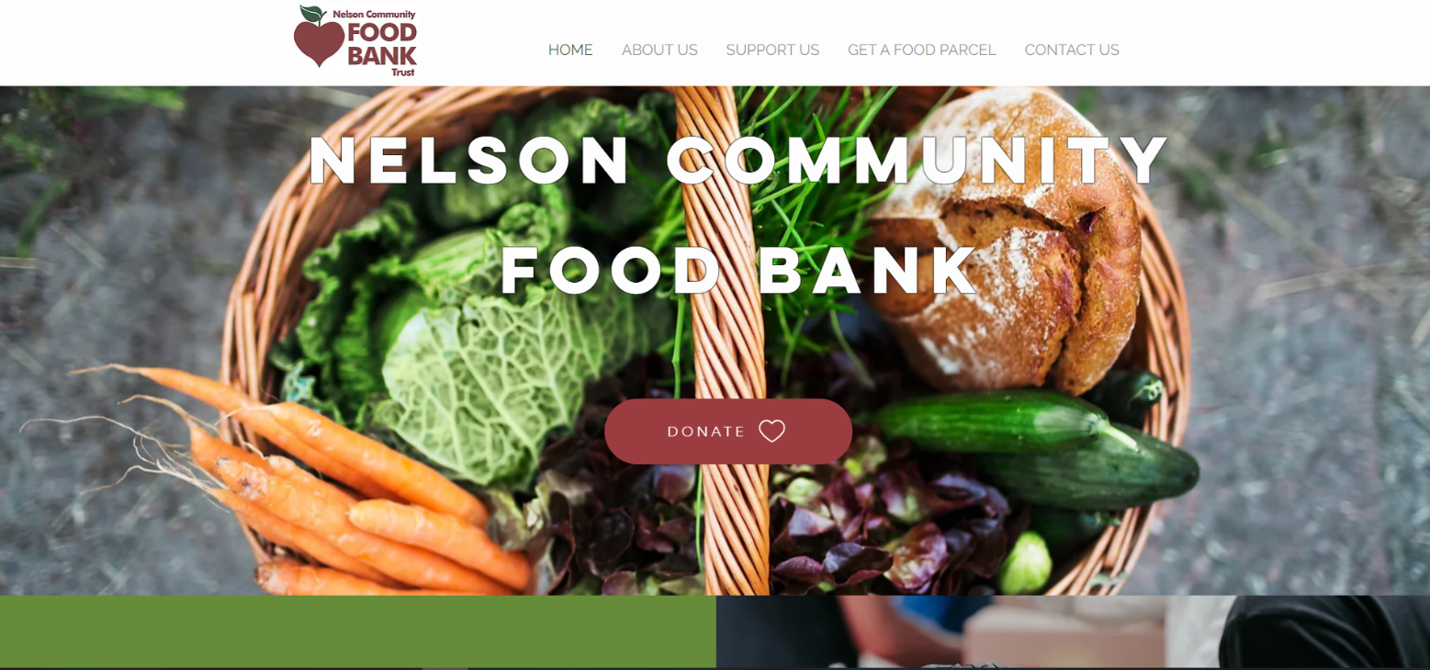

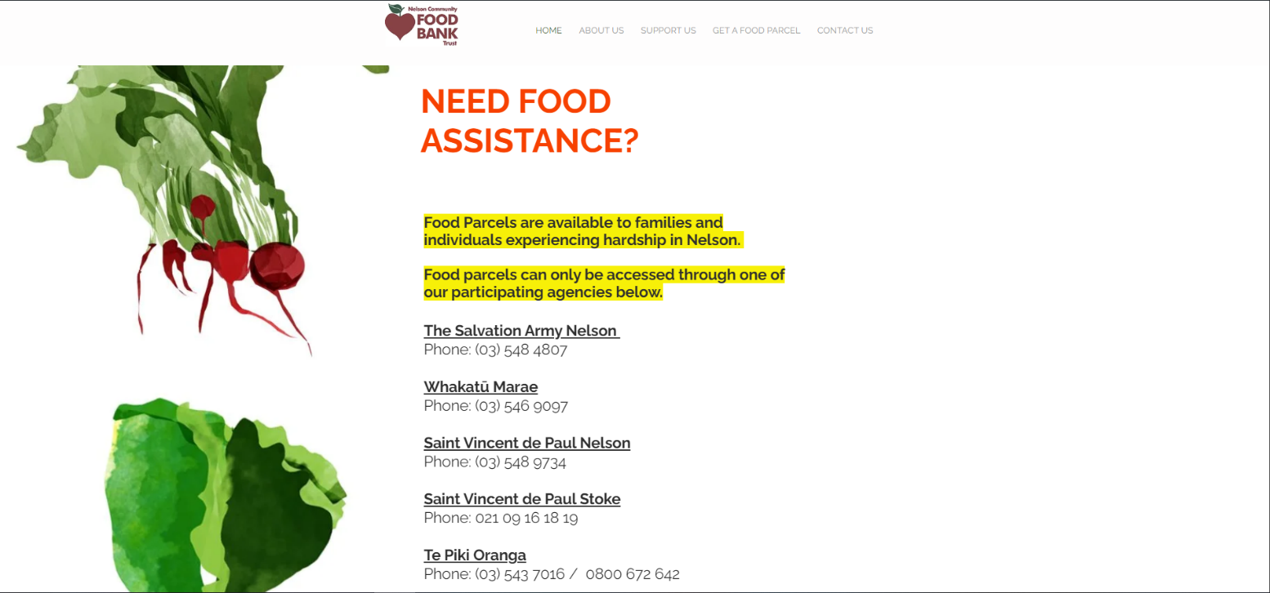

**Teddy NZ:**

The Teddy website’s design is minimal but done in a clean and simple way that makes it look nice and inviting for users. They use bright colors, clear bold text and relevant images regarding groceries. The user experience of the website is almost non-existent with all functionality and usage of the web app just refers to downloading their mobile application which is poor in my opinion.

Like the previous website, Teddy is a single webpage site with all information being fit into a single page but this time it is done in a tidy manner. The flow of the website is good with the initial landing page having a small but well written description of what, where and how of the application. Although they use a single webpage, most of the unimportant information is hidden behind tabs which helps clean the page up and stop the user from feeling overwhelmed at a first glance.

Their footer content is clean and well sorted with an easy-to-read font and having important links like customer support, social media links and company enquiries.

A large weakness of their website Is that a user cannot use their service without the mobile application, which limits their target audience and user engagement. A good idea would be to allow the service to be used from the website alongside the mobile application.

*Screenshots for reference below:*

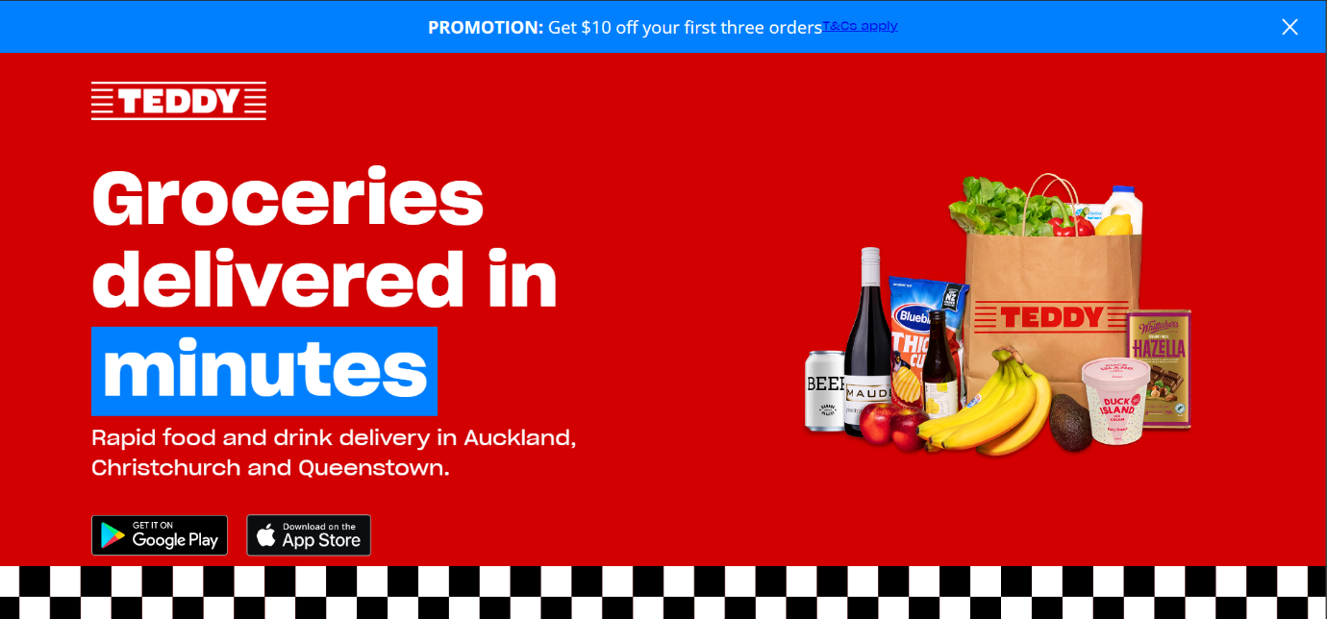

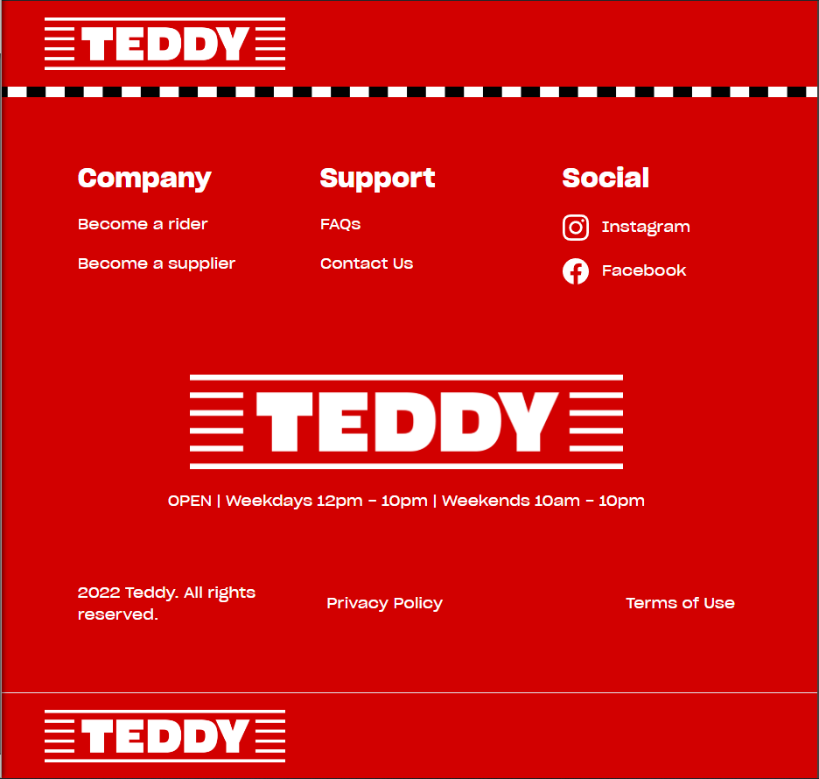

## Site Content

### Content and Functional Requirements

**Home Page:**

* **Welcome message:** Introduction to the Grow & Give charity service and a brief mission statement on its contribution to community members in need through donations
* **Overview of services:** Brief explanation of the how the platform works, including donation/beneficiary process
* **Buttons:**
  + Register as a Donor
  + Register as a Beneficiary
  + Learn morn

**About Us Page:**

* **Mission statement:** Charity’s mission and vision statement about the goals and purpose of the organization
* **Story:** Background of the organization and impact it aims to make in the community
* **Partners and Sponsors:** Information about the partnerships with local farms, businesses and community organizations

**Donor Page:**

* **Registration:**
  + Form for registering as a donor
  + Has required fields like Name, Business name? Contact information, Location, Types of produce for donation, etc.
* **Donation Management:**
  + Dashboard where donors can list available donations, update exiting listing or remove any donation listing
  + Notifications for new requests from beneficiaries about upcoming packages?

**Beneficiary Page:**

* **Registration:**
  + Form for registering as a beneficiary
  + Have required fields such as Name, Contact information, ways to verify and confirm eligibility
* **Voucher Claim:**
  + Interface section for beneficiaries to acquire a code/voucher. Maybe view account balance?
  + Information on how vouchers work and how to redeem them
* **Browse available produce:**
  + Listings of the current available donations, with details such as item type, quantity, pickup location and status
  + Option to reserve? If so, instructions on where and when to pick up package

**Recipes and Tips Page?**

* **Healthy recipes:**
  + Articles and recipes that incorporate fresh produce
  + Categories based on difficulty level, meal type and dietary preferences.
* **Health tips:**
  + Information on the nutritional benefits of health eating and how they contribute to a better lifestyle
  + Seasonal eating guides such as tips for storing fresh produce and advice on reducing food waste?

**Contact us Page:**

* **Contact form:** Simple form for general enquiries or volunteer sign ups
* **FAQs:** Frequently asked questions about the platform, donation process, token system and other aspects.

### Grouping and Labeling

**Main Navigation Content:**

* Home
* About us
* Register/Login
* Profile
* Produce Listings
* Recipes
  + Healthy Recipes
  + Tips
* Contact us
  + FAQs
  + Contact Form

**Footer Content:**

* Privacy Policy
* Terms and Conditions
* Social Media Links
* Basic contact Information

**Landing Page Content:**

* Introduction and mission statement
* Brief Overview of how the platform works
* Navigation buttons for registration and about us page

**Login/Registration Content:**

* Form for either registration or login for both donors and beneficiaries

**Donor Content:**

* Donation management dashboard
* Notifications and alerts?

**Beneficiary Content:**

* Voucher acquisition
* Browse available produce listings

**Educational Content:**

* Healthy recipes and tips

**User support Content:**

* Contact form
* FAQs
* Other support information

## Site Structure

### Metaphors

**1. Organizational Metaphor: "Marketplace"**

* The site’s structure is similar to a marketplace where products/goods (fresh produce) are offered by donors and selected by beneficiaries
* Donors act as vendors or suppliers listing their available produce
* Beneficiaries act as customers browsing the available produce and using vouchers as currency to claim items.
* This metaphor shapes the layout and hierarchy, with the aim of clear listings, categories, and a checkout-like process

**2. Functional Metaphor: "Library System"**

* The website functions like a library system where items (produce) are catalogued, categorized, and checked out using vouchers
* The "catalogue" is the produce listing, organized by type, availability, quantity, and location.
* The "checkout process" involves beneficiaries claiming vouchers and requesting a produce package.
* This metaphor expresses searchability, filters, and managing accounts

**3. Visual Metaphor: "Produce Stall”**

* Visually, the site resembles a fruit/vege stall, showcasing the local freshly grown produce
* Earthy tones and related images could be used to represent fresh produce.
* Simple visual elements like baskets, crates, and open layouts create a welcoming feel for users.
* Icons and imagery (e.g., berry/fruit/vegetable images)

### Site Structure Listing

**Home**

│

├── **About Us**

│ ├── Our Goal

│ ├── Our Story

│ └── Partners and Sponsors

│

├── **Donate (Donor Section)**

│ ├── Register as a Donor

│ ├── Manage Donations

│ └── Notifications and Alerts

│

├── **Get Fresh Produce (Beneficiary Section)**

│ ├── Register as a Beneficiary

│ ├── Claim Vouchers

│ └── Browse Available Produce

│

├── **Recipes & Tips**

│ ├── Healthy Recipes

│ ├── Health Tips

│ │ ├── Nutritional Benefits

│ │ └── Seasonal Eating Guides

│

│

├── **Contact Us**

│ ├── Contact Form

│ └── FAQs

│

└── **Footer**

├── Privacy Policy

├── Terms and Conditions

└── Social Media Links

### Architectural Blueprint

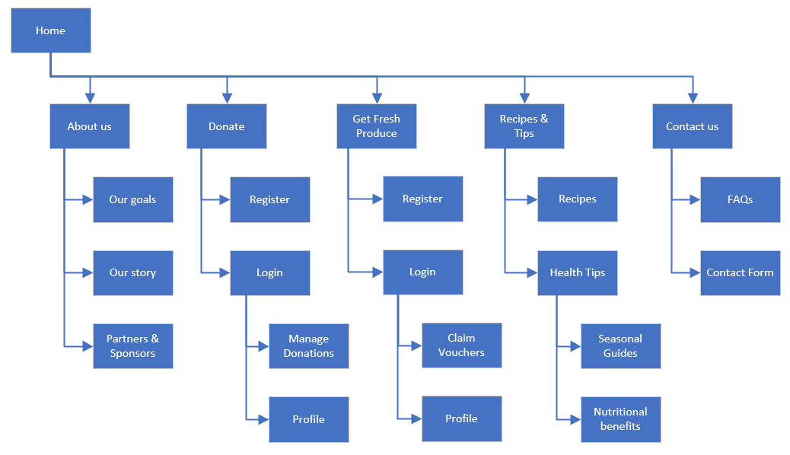

### Define Navigation

**Global Navigation:**

The global navigation appears at the top of every page and includes the following links:

* **Home**
* **About Us**
* **Donate (Donor Section)**
* **Get Fresh Produce (Beneficiary Section)**
* **Recipes & Tips**
* **Events & Community**
* **Contact Us**
* The global navigation is consistent across all pages and uses a simple drop-down menu for any section with subpages (Recipes and Tips for example)

**Local Navigation:**

* The local navigation appears within specific sections and includes links to relevant subsections but in this current iteration of the charity website, I don’t plan on incorporating any local navigation and only rely on the global navigation and possibly some breadcrumbing to help users see where they are within the site’s hierarchy (e.g., Home > Get Fresh Produce > Browse Available Produce).

**Footer Navigation:**

* The footer contains links to important informational pages like Privacy Policy, Terms and Conditions, and social media channels. It also includes a sign-up option for the newsletter.

## Visual Design

### Home Page

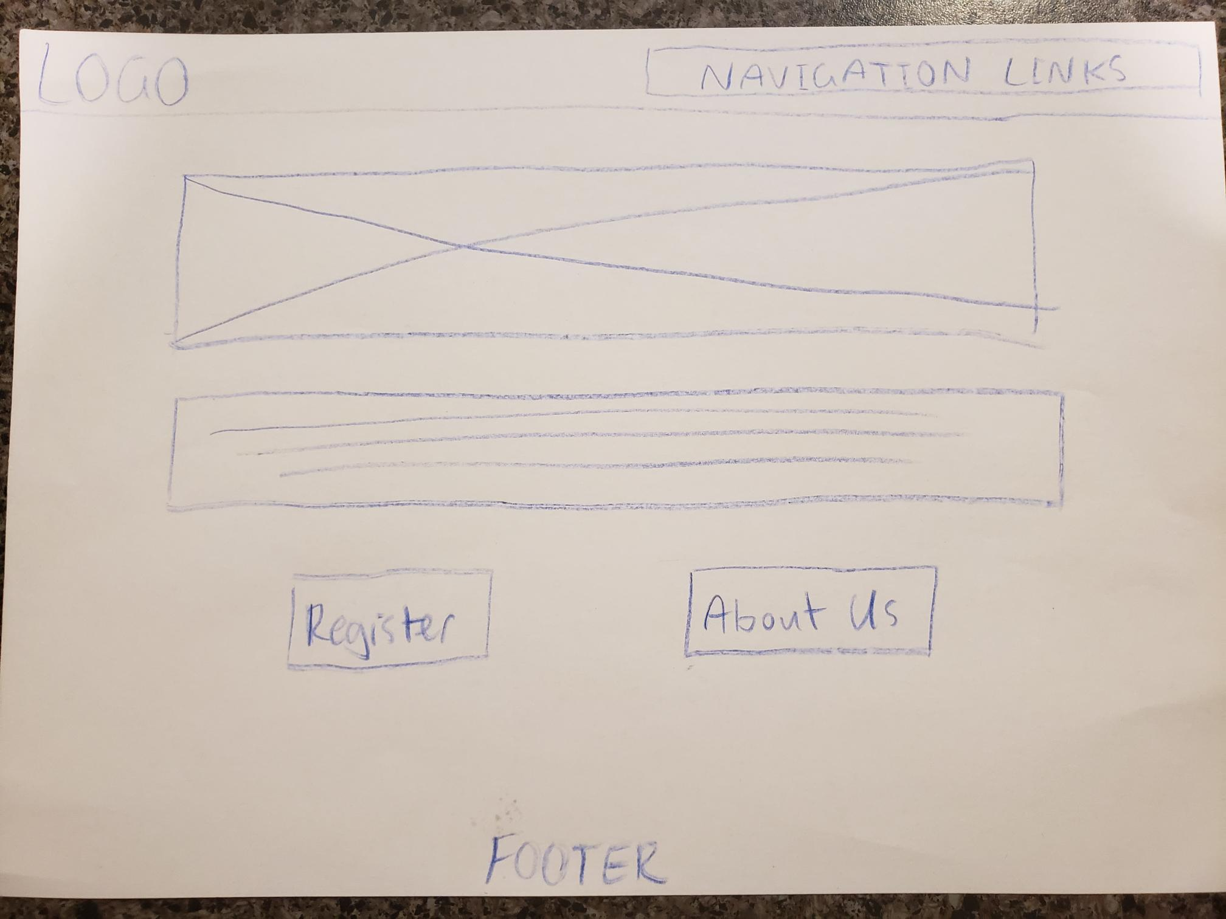

### About Us Page

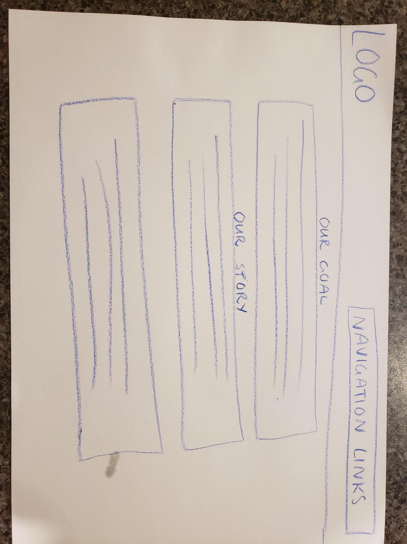

### Contact Us Page

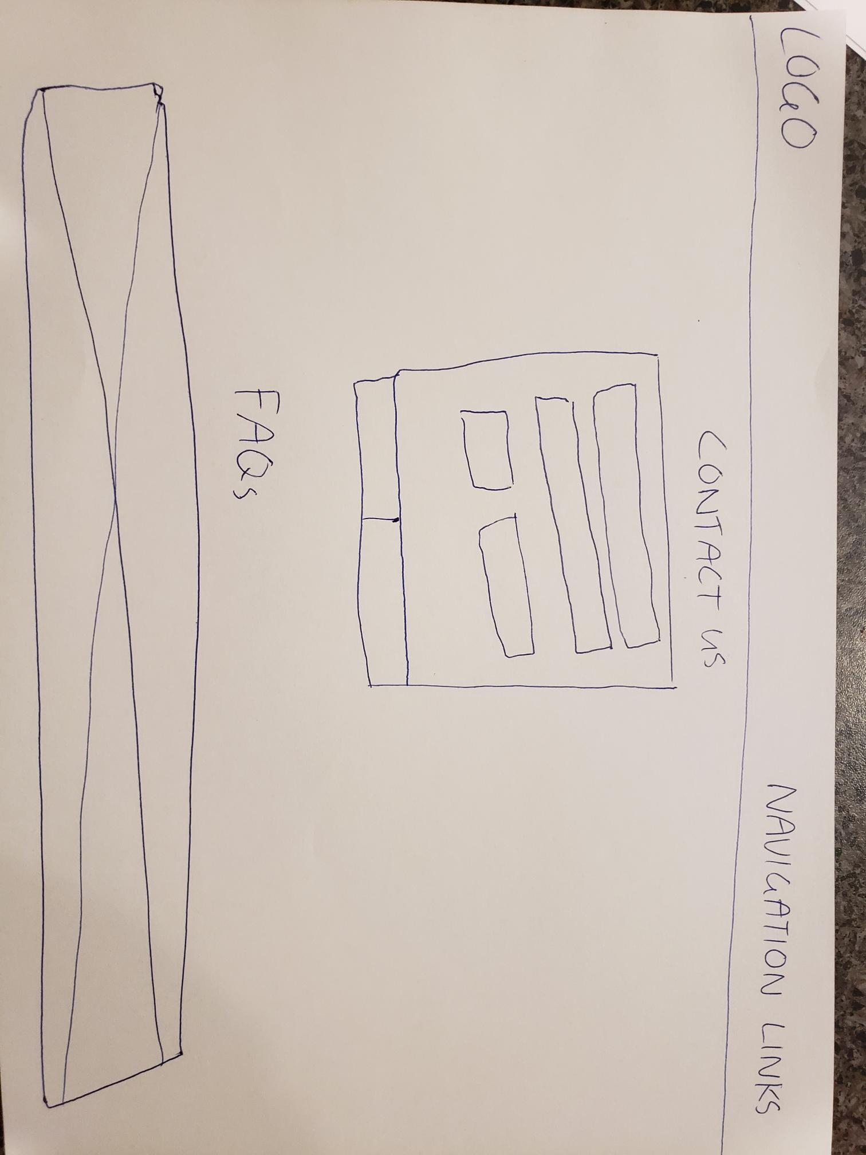

### Register/Login Page

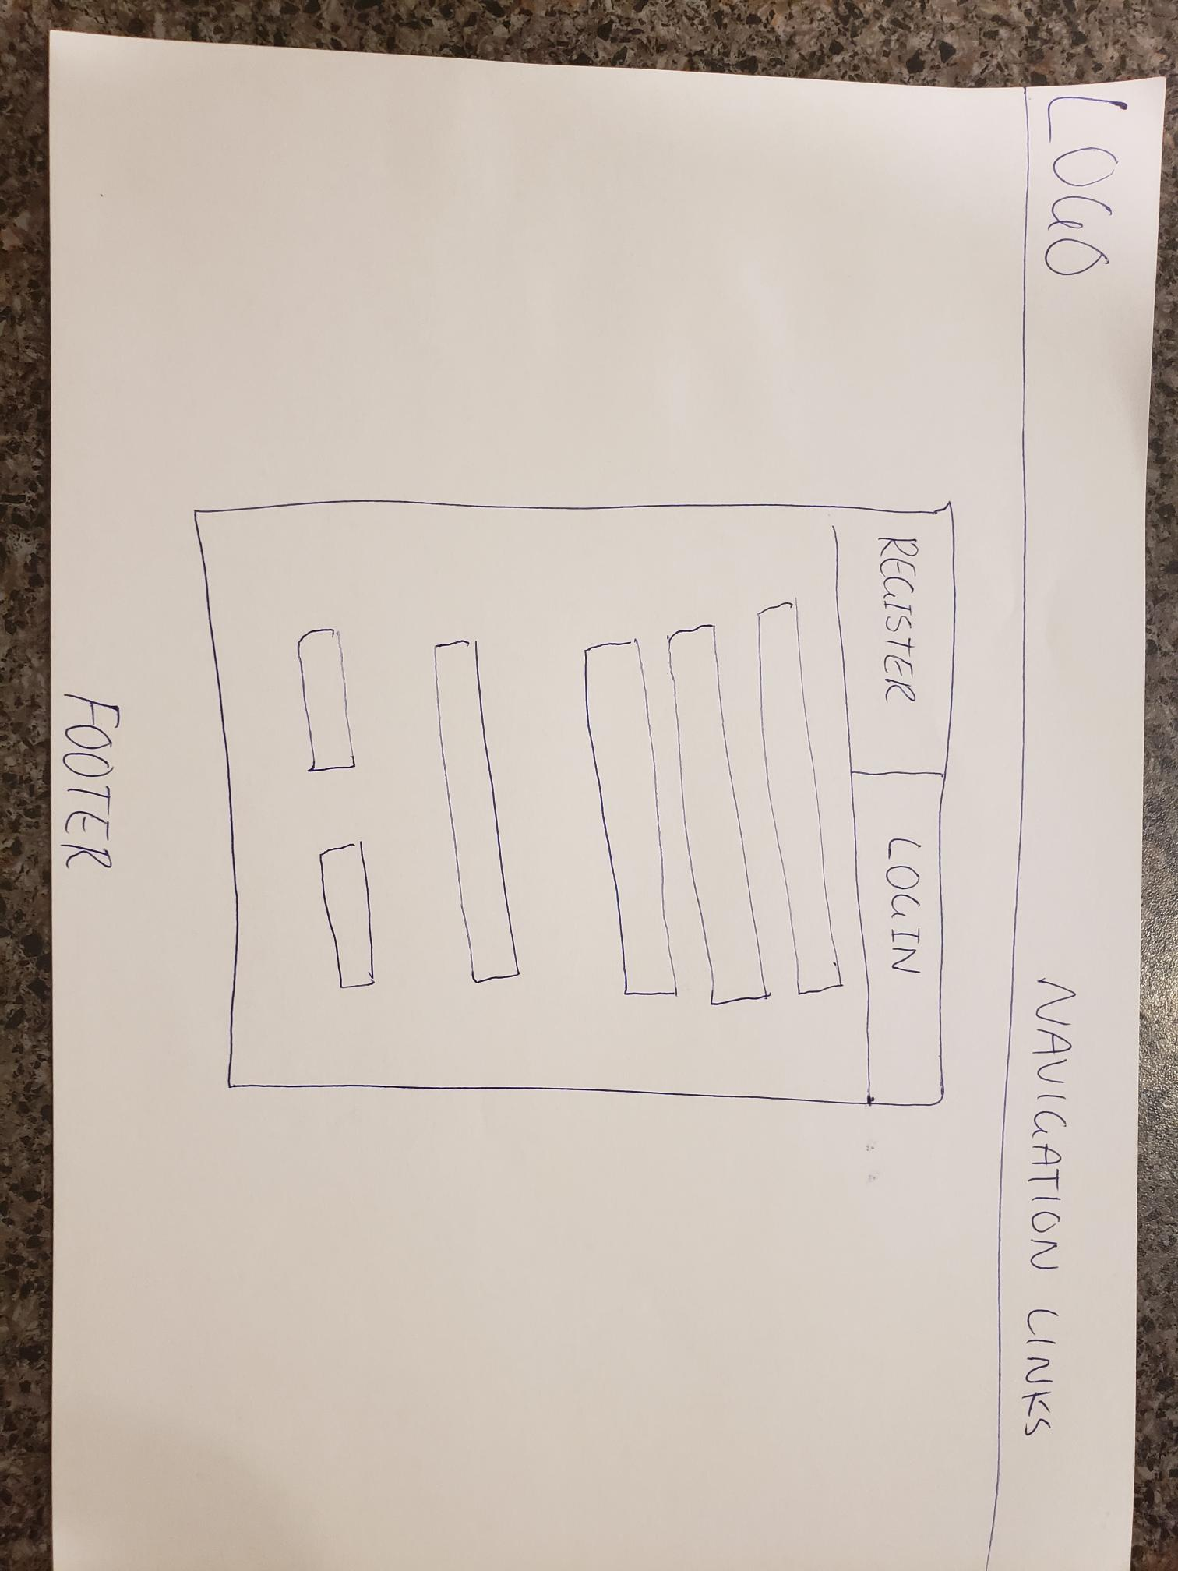

### Profile Page

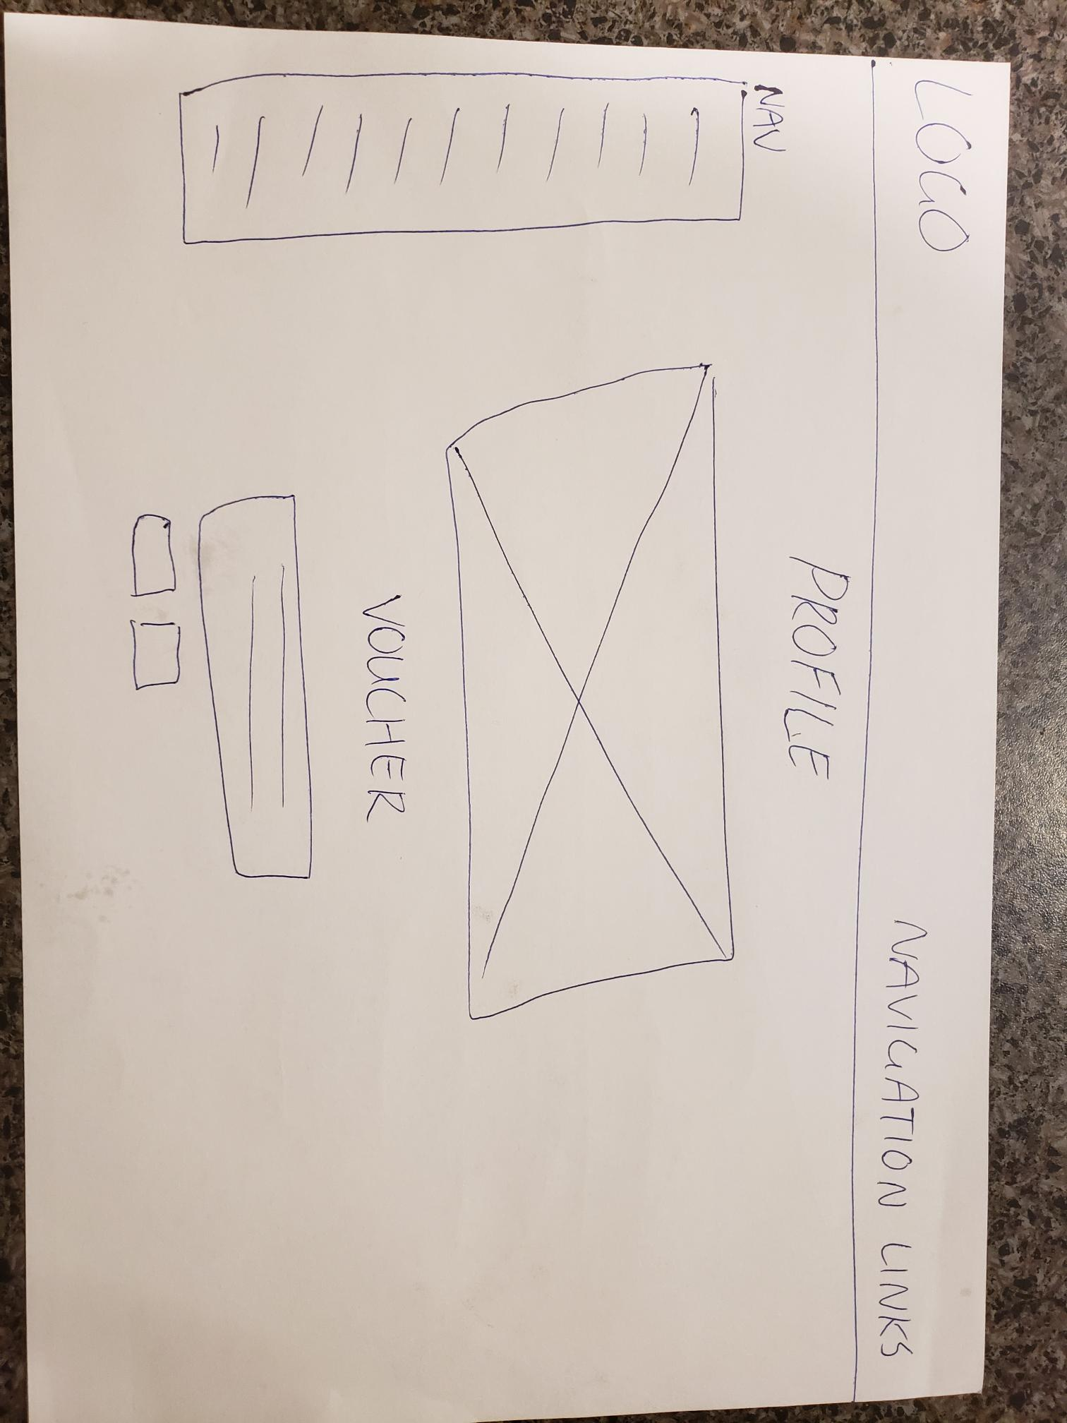

### Donation Dashboard Page

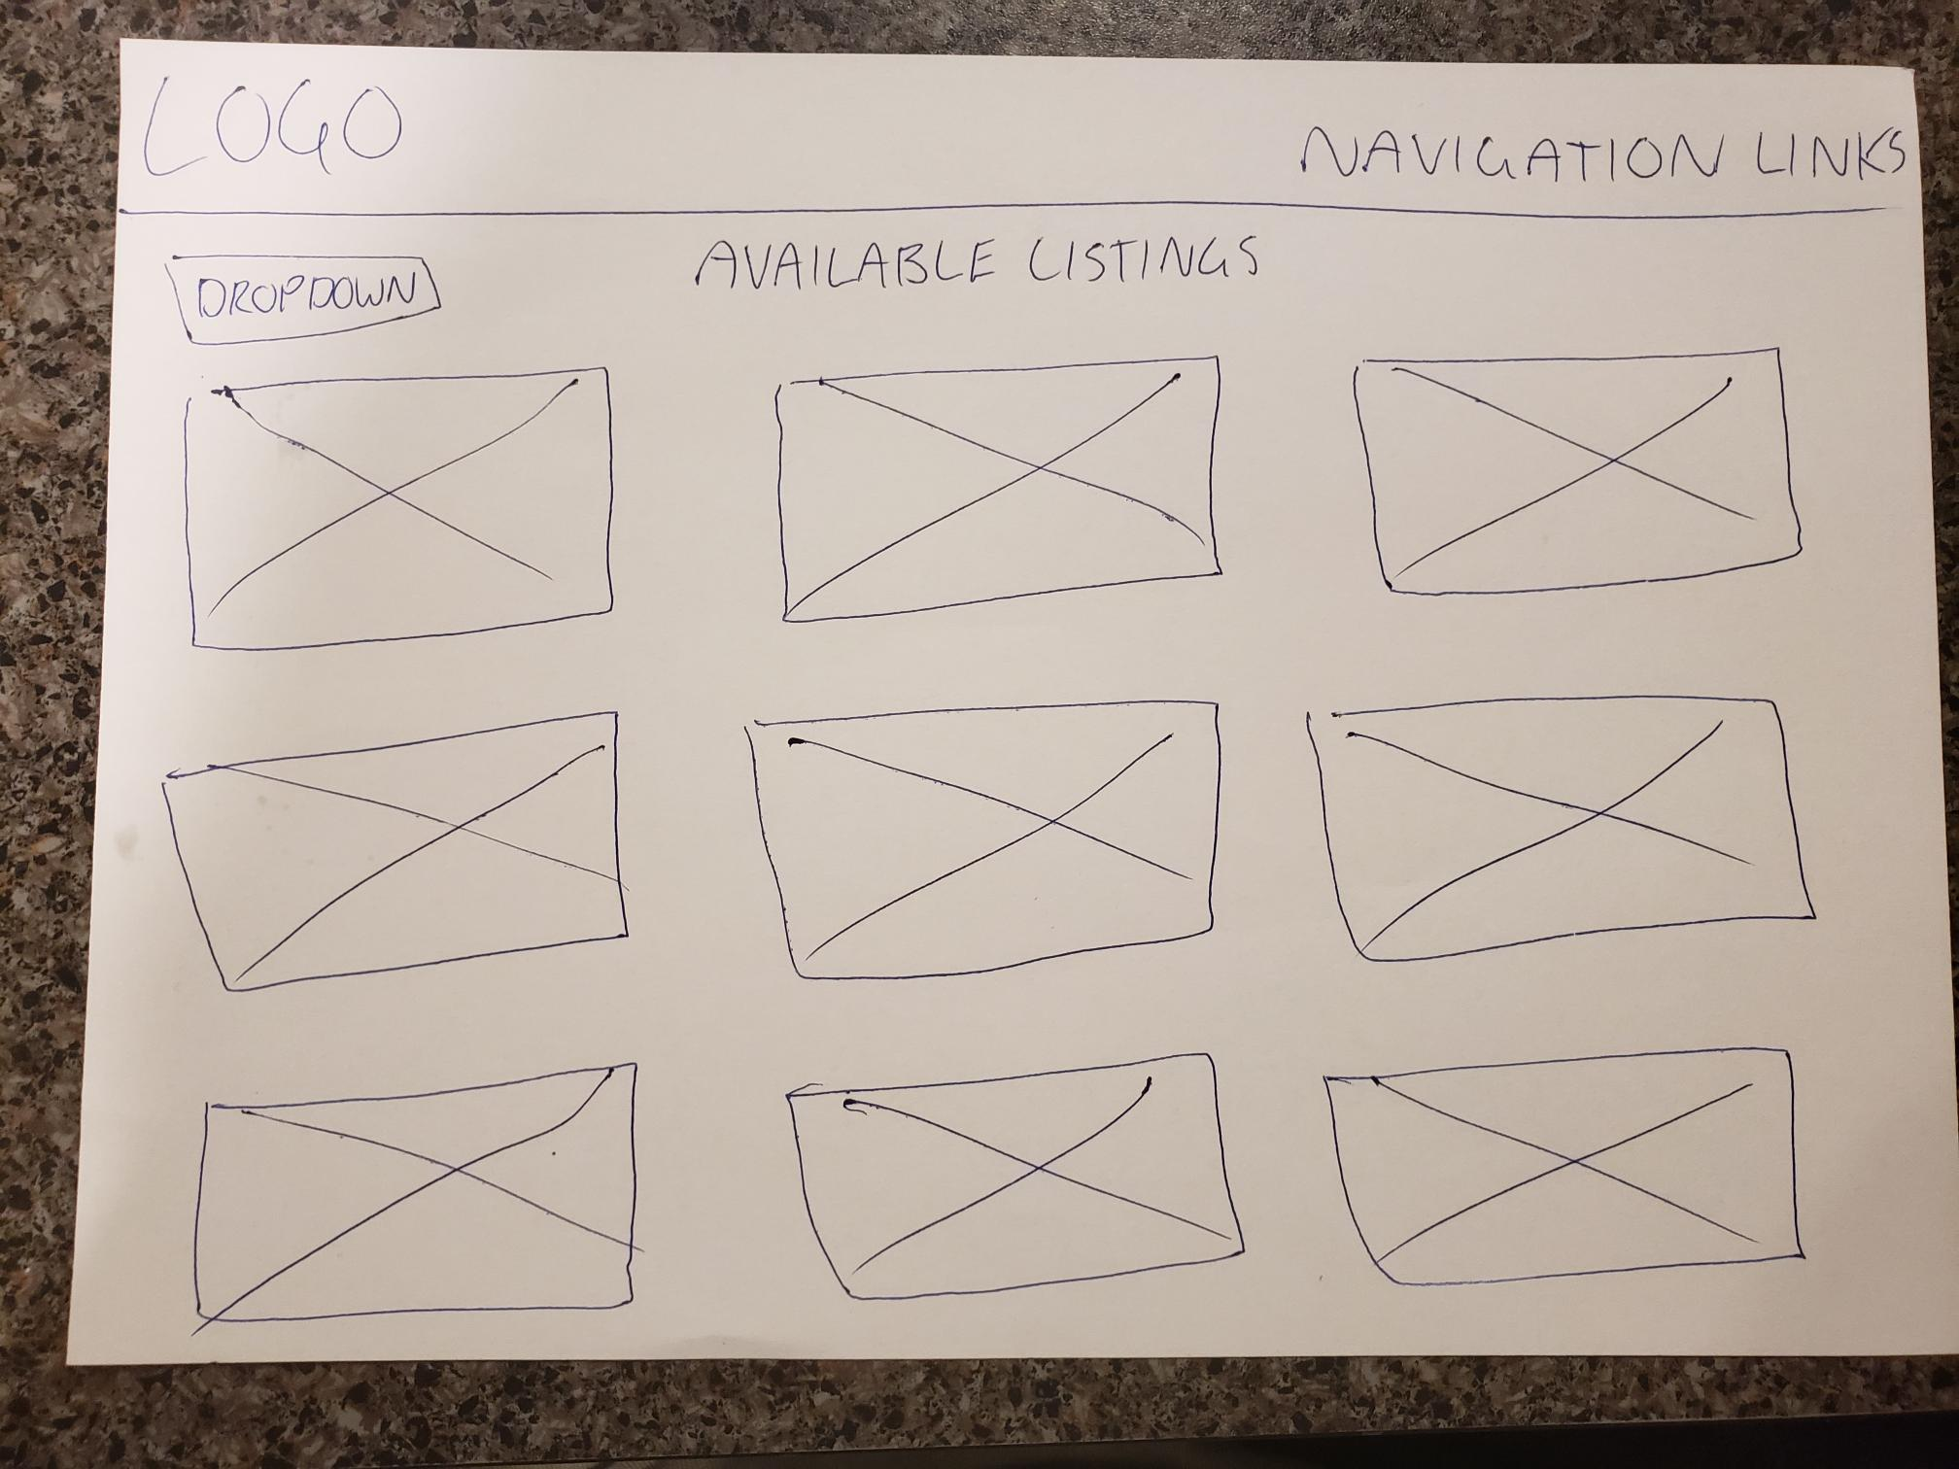

### Recipe/Health Tip Page

